**Qualitative tests for detection of proteins**

**Biuret test**

This test is used to detect the presence of peptide bond. When treated with copper sulphate solution in presence of alkali (NaOH or KOH), protein reacts with copper (II) ions to form a violet coloured complex called biuret.

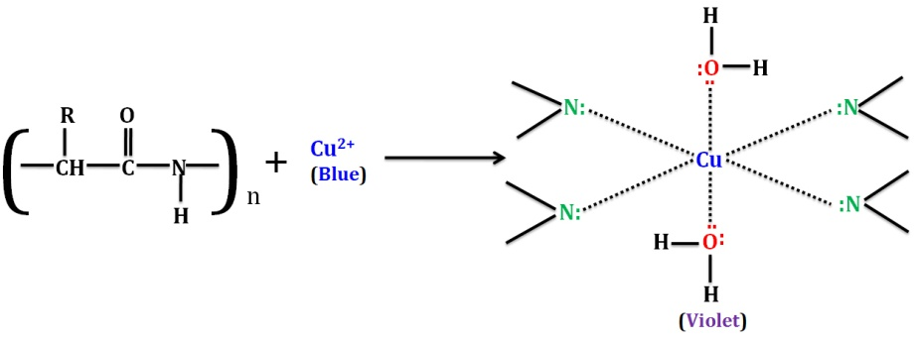

Compounds containing two or more peptide bonds react with cupric ions (Cu2+) in alkaline solution to produce a complex of reddish-purple colour indicating the presence of proteins. The Biuret test for proteins may also be **extended**to quantitatively measure the **concentration of total protein** using spectrometric methods. The Biuret reagent contains

* Hydrated Copper sulphate
* Potassium hydroxide solution
* Potassium sodium tartrate

In the presence of proteins the blue biuret’s solution turns purple. The purple color intensity indicates the amount of protein present such that a deep purple indicates large protein concentration in sample while a pale purple indicates low protein concentration

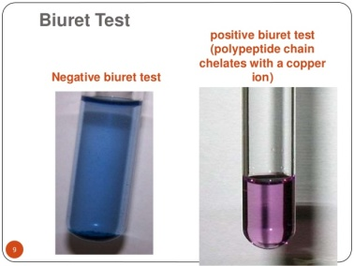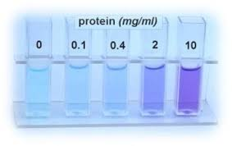

Biurets is usually sensitive to high protein concentrations but not low concentrations of protein.

**Xanthoproteic test**

It is an identification test of protein and it gives a positive result with those proteins with amino acid carrying aromatic group. When protein is treated with hot concentrated nitric acid, a yellow coloured substance is formed. The yellow colour is due to xanthoproteic acid which is formed by the nitration of certain amino acids present in protein such as tyrosine and tryptophan.

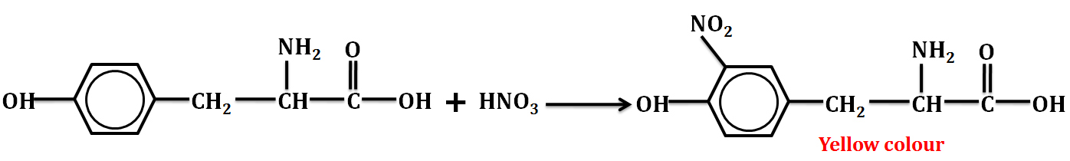

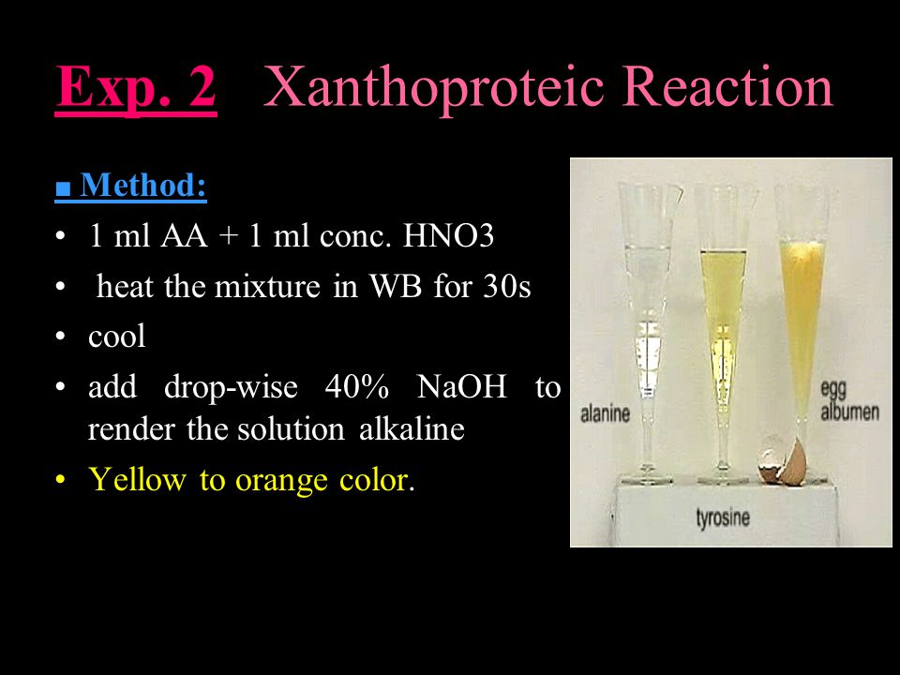

**Ninhydrin test**

This is a test for amino acids and proteins with free –NH2 group. When such an –NH2 group reacts with ninhydrin, an intense blue/purple coloured complex is formed.

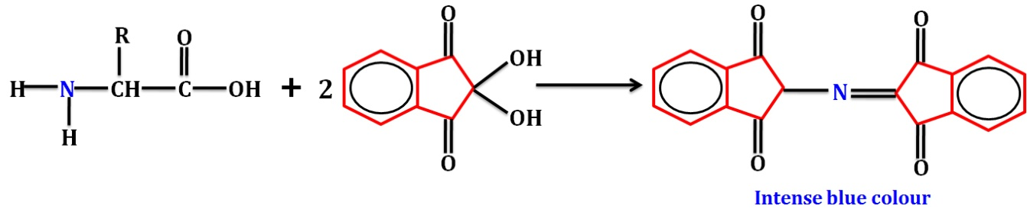

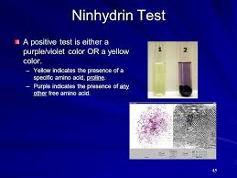

Where purple color shows the presence of any other amino acids but proline indicates a positive yellow color with ninhydrin test

**Millon’s test**

When egg albumin is treated with Millon’s reagent, it first gives a white coloured precipitate which then changes to brick red on boiling. Gelatin does not give this test. A reddish-brown coloration or precipitate indicates the presence of [tyrosine](https://en.wikipedia.org/wiki/Tyrosine) residue which occur in nearly all proteins.

[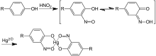](https://en.wikipedia.org/wiki/File:Millon_Reaction_Principle_V.1.svg)

Millon's test is not specific for proteins (it detects [phenolic](https://en.wikipedia.org/wiki/Phenols) compounds), and so must be confirmed by other tests for proteins such as the [biuret test](https://en.wikipedia.org/wiki/Biuret_test) and the [ninhydrin](https://en.wikipedia.org/wiki/Ninhydrin" \o "Ninhydrin) reaction. The reagent is made by dissolving metallic [mercury](https://en.wikipedia.org/wiki/Mercury_(element)) in [nitric acid](https://en.wikipedia.org/wiki/Nitric_acid) and diluting with water

**Lowry assay**

The assay is based on reduction of the Cupric Cu2+ to cuprous ions Cu+ in alkaline pH when reacting with peptide. Cuprous ion and the phenolic group of Tyr; indole of Trp; -SH of Cys then react with Folin-Ciocalteau reagent to produce an unstable “molydenum blue”-type product (that absorbs light at a wavlenth of 650nm). The reagent consists of phosphomolybdate and phosphotungstate which create the color when reduced. Most proteins contain little Trp or Cys. Therefore, the colour here is largely due to Tyr content. The Lowry method is sensitive to low concentrations of protein of concentrations ranging from 0.10 - 2 mg of protein per ml or 0.005 - 0.10 mg of protein per ml. The major disadvantage of the Lowry method is the narrow pH range within which it is accurate which is 10-10.5 alkaline pH.

**Bis-cinchinonic acid (BCA) assay**

The bis-cinchinonic acid (BCA) assay for total protein is a spectrophotometric assay based on the alkaline reduction of the cupric ion to the cuprous ion by the protein at pH 11.5, followed by chelation and color development by the BCA reagent. The total protein concentration is exhibited by a color change of the sample solution from green to purple in proportion to protein concentration, which can then be measured using spectrophotometric techniques as the complex absorbs light maximally at a wavelength of 562 nm. Cu2+ ions reduced to Cu+ ions by aromatic amino acids. Cu+ ions and Bicinchoninic Acid ® Complex has absorption maximum at 562 nm. It is sensitive to low protein concentration of 0.5 μg/mL to 1.5 mg/mL. A stock BCA solution contains the following ingredients in a highly [alkaline](https://en.wikipedia.org/wiki/Alkaline) solution with a [pH](https://en.wikipedia.org/wiki/PH) 11.25: [bicinchoninic acid](https://en.wikipedia.org/wiki/Bicinchoninic_acid" \o "Bicinchoninic acid), [sodium carbonate](https://en.wikipedia.org/wiki/Sodium_carbonate), [sodium bicarbonate](https://en.wikipedia.org/wiki/Sodium_bicarbonate), [sodium tartrate](https://en.wikipedia.org/wiki/Sodium_tartrate), and [copper(II) sulfate](https://en.wikipedia.org/wiki/Copper(II)_sulfate)/pentahydrate.

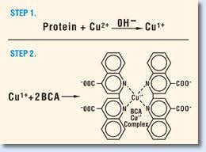

**Bradford assay**

This assay is based on binding of Coomassie dye (Brilliant blue G250) by protein under acidic conditions results in a color change from brown to blue. If there's no protein to bind then, the solution will remain brown. The dye forms a strong, noncovalent complex with the protein's carboxyl group by Van der Waals force and amino group through electrostatic interactions. During the formation of this complex, the red form of Coomassie dye first donates its free electron to the ionizable groups on the protein, which causes a disruption of the protein's native state, consequently exposing its [hydrophobic](https://en.wikipedia.org/wiki/Hydrophobic) pockets. These pockets in the protein's [tertiary structure](https://en.wikipedia.org/wiki/Tertiary_structure) bind non-covalently to the non-polar region of the dye via the first bond interaction ([van der Waals forces](https://en.wikipedia.org/wiki/Van_der_Waals_force)) which position the positive amine groups in proximity with the negative charge of the dye. The bond is further strengthened by the second bond interaction between the two, the ionic interaction. The binding of the protein stabilizes the blue form of the Coomassie dye; thus the amount of the complex present in solution is a measure for the protein concentration, and can be estimated by use of an absorbance reading at 595 nm. The dye binds to aromatic amino acids Tryptophan, Tyrosine, Phenylalanine. Advantage of this method is that it is easy to use compared with Biuret, Lowry, and BCA. Disadvantage; more sensitive for other substances, eg detergents for example the presence of SDS even at low concentrations can interfere with protein-dye binding.